Logan Hammond

3 March 2020

SDEV 300, Fair

Lab 7 Results Document

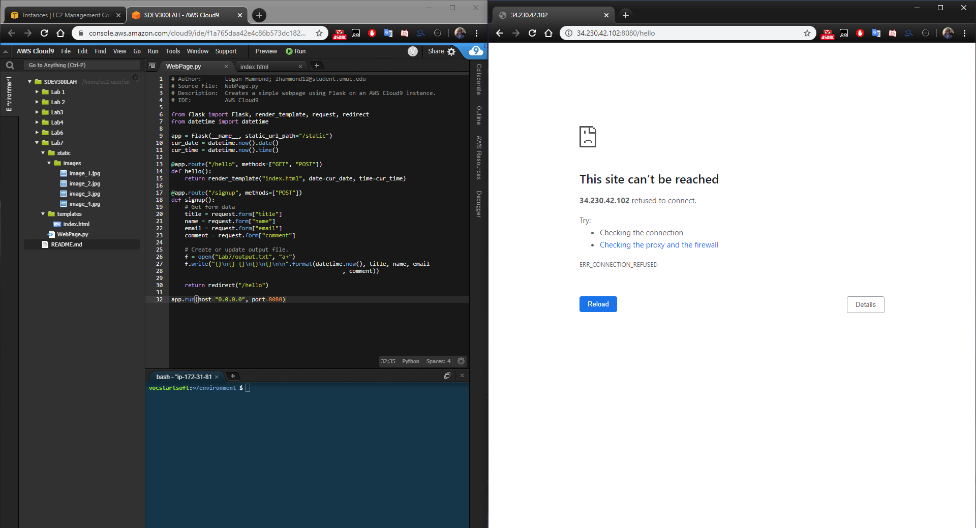

Before the program is started the website cannot be reached.

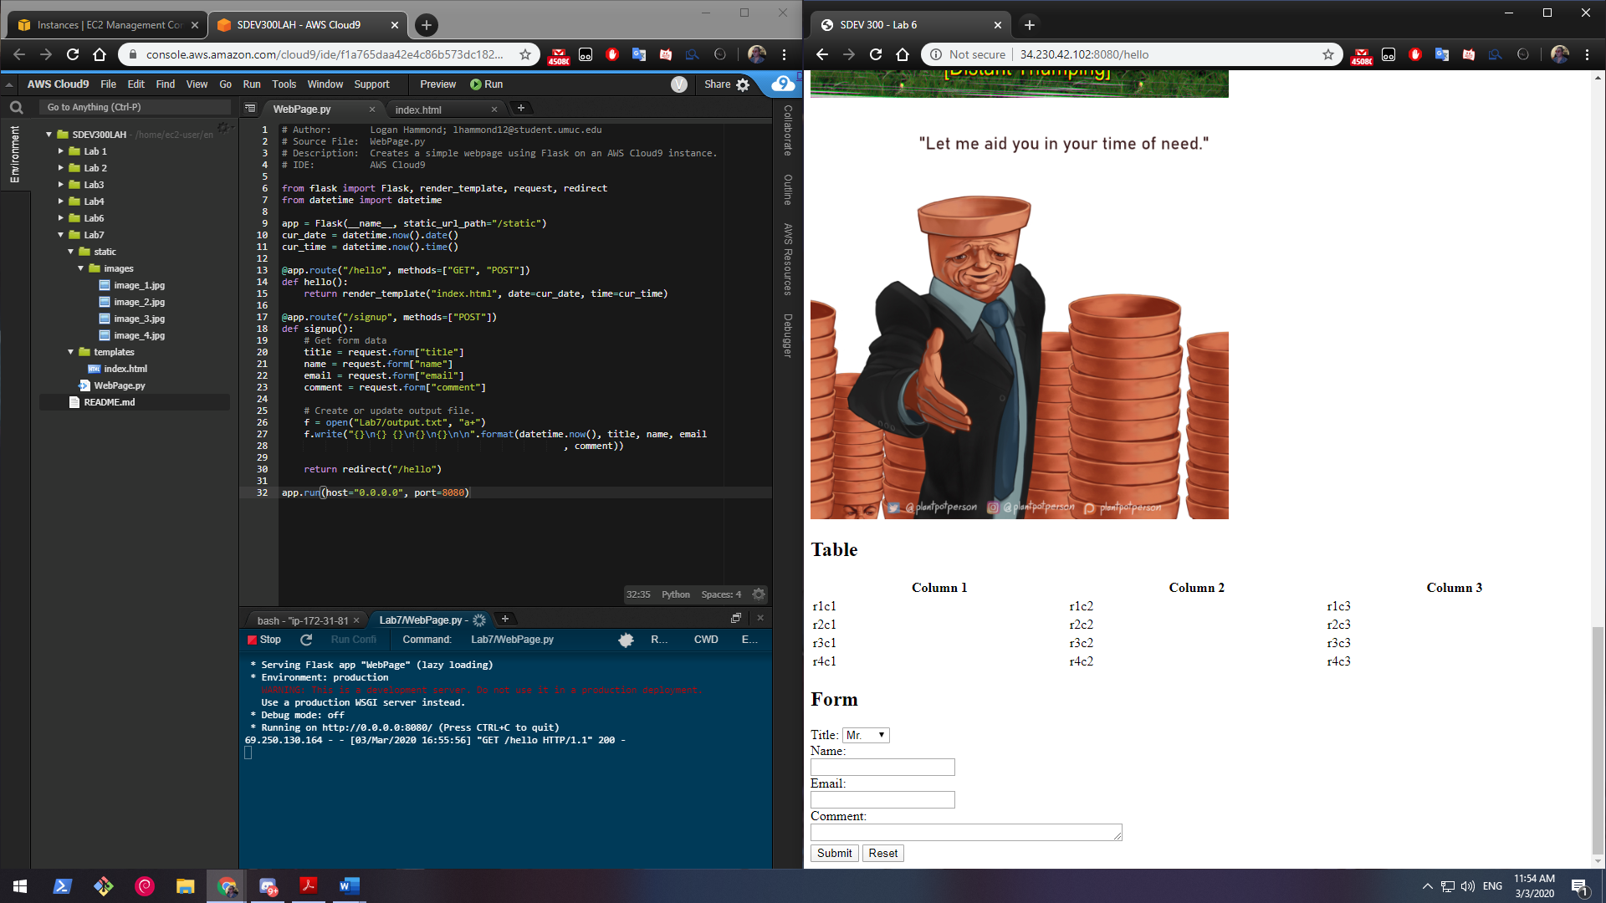

Once the program is running the website is accessible. Homepage of site at time of photo was <http://34.230.42.102:8080/hello>. Image shows program running and non-local access to site.

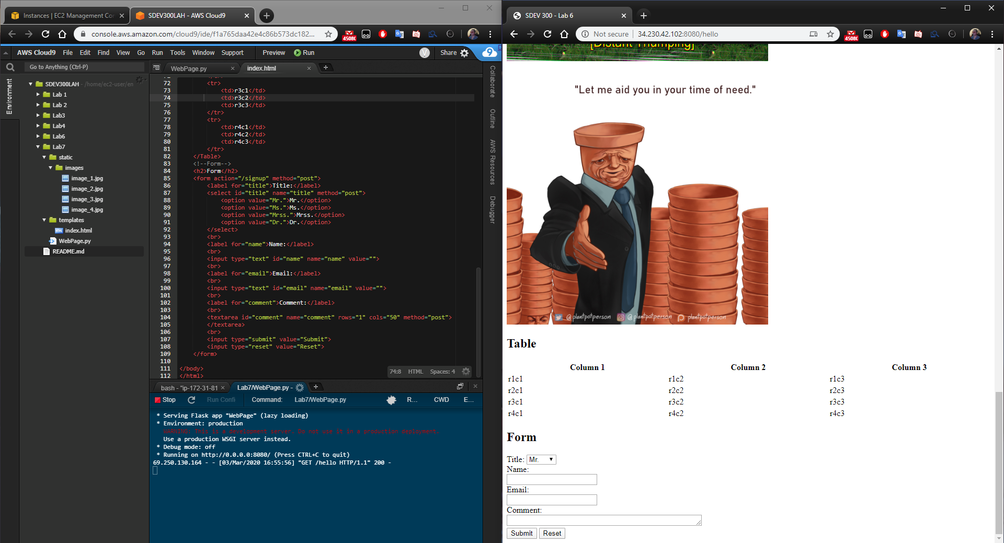

Image shows the file structure of the project and its index.html file. End of table and entire form can be seen in the index.html from the image.

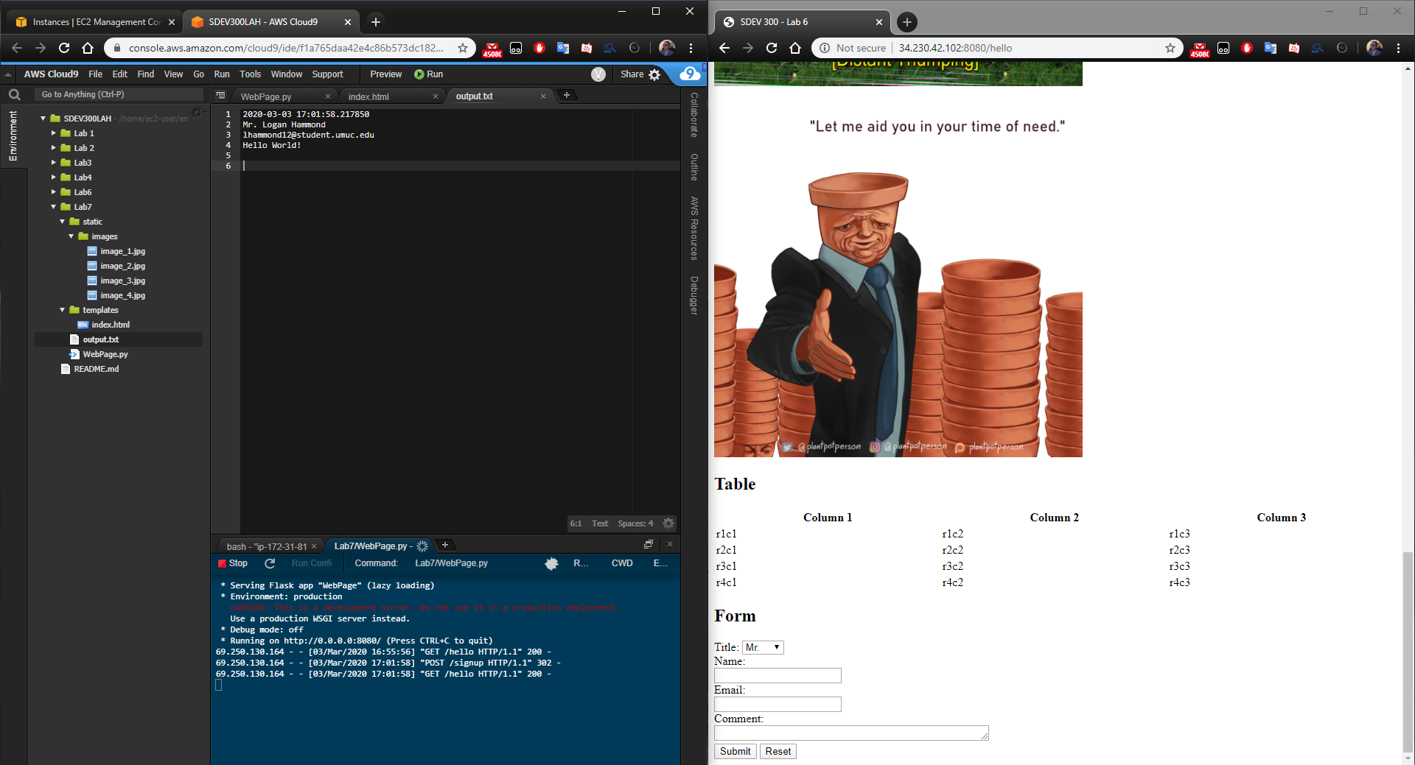

When the form is submitted the program creates the output file (if it does not already exist) containing a timestamp and the data from the form. On form submission the user is redirected back to the homepage.

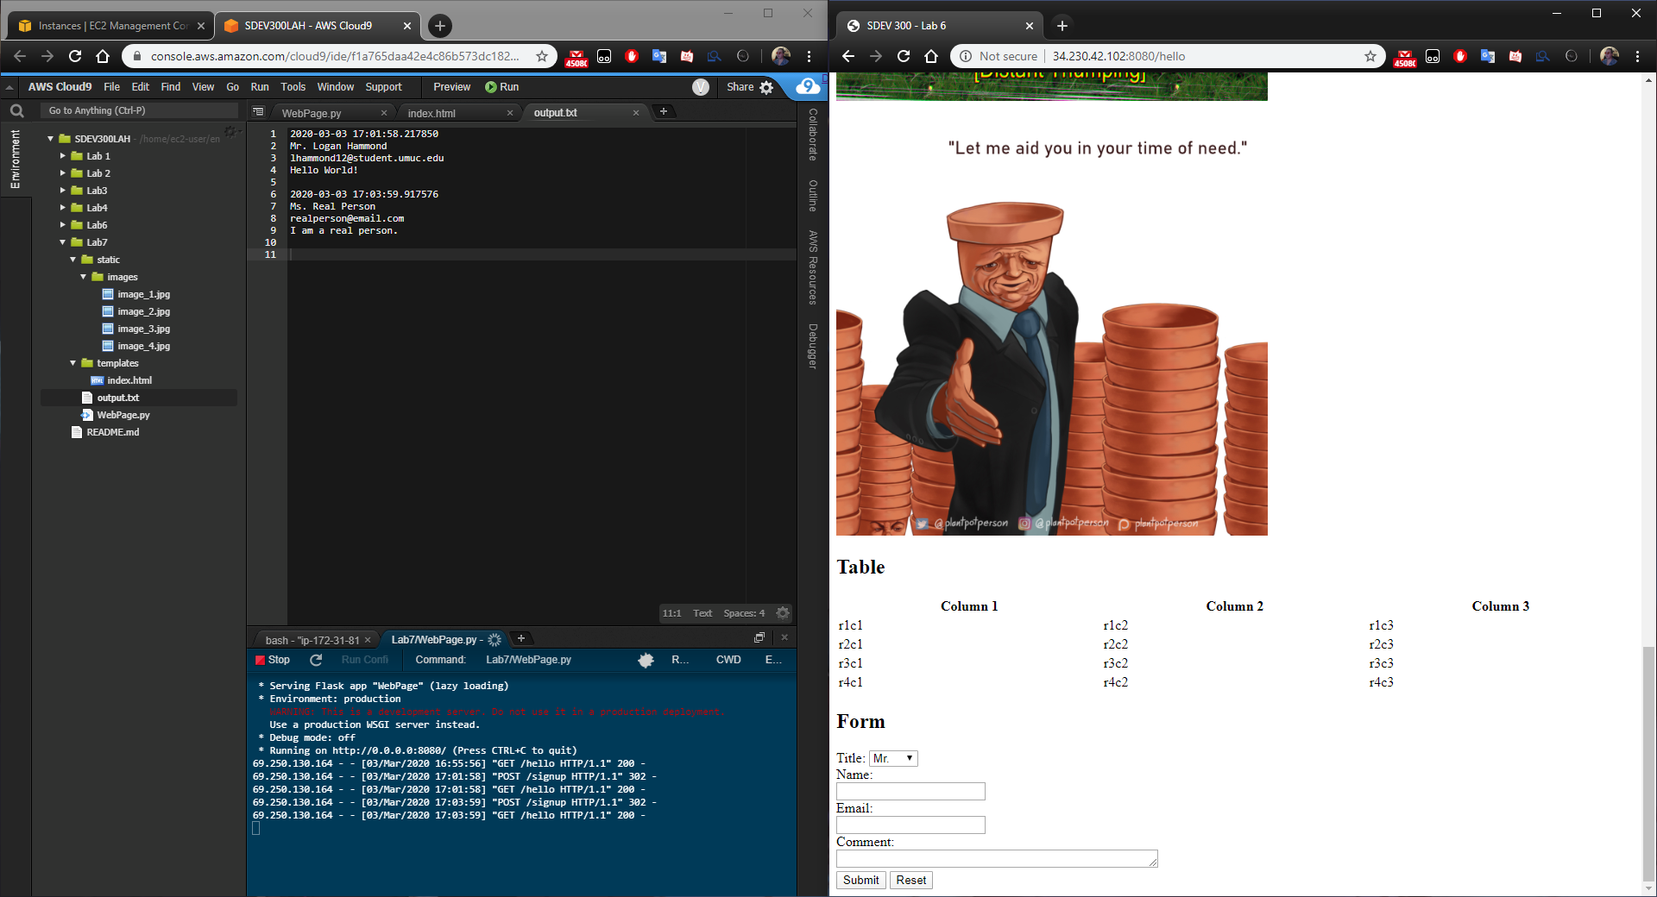

When another form is submitted the new data is appended to the pre-existing output file.